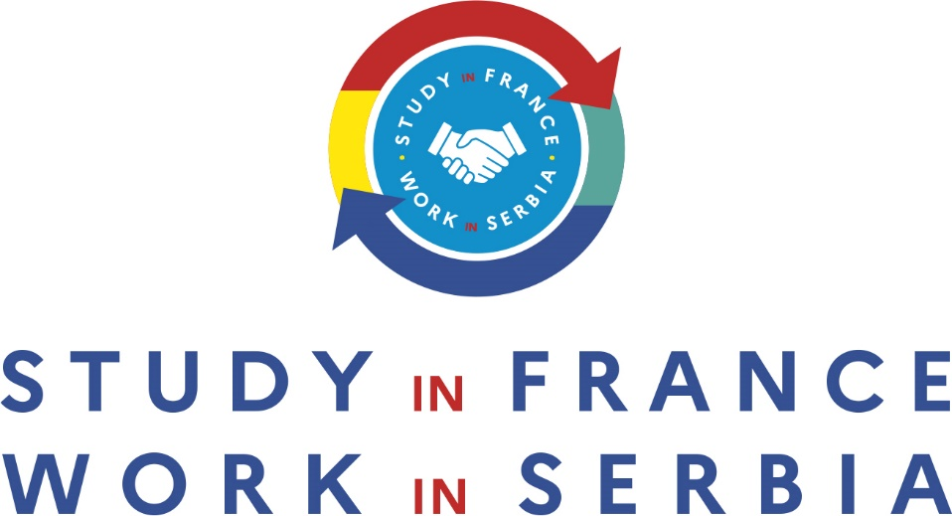

Studies and job opportunities in the sustainable infrastructure construction sector
November 25th at the University of Belgrade, Faculty of Architecture Svecana Sala

Draft Agenda:
10:40 Registration & Coffee
11:10 Introduction by the moderator, Mrs. Jelisaveta Lazarevic (AFA)
11:15 Opening addresses by:
- Pr. Vladimir Lojanica, Dean of Belgrade Architecture faculty ;
- M. Stanislas Pierret, Director of the French Institute in Serbia;
11:25 Agreement signature between ESTP Paris and University of Belgrade / official picture
11:30 Mrs. Borina Andrieu, Advisor to the National Committee of French Foreign Trade
( CNCCEF ) & Managing director of Wilmotte et associés architects: Presentation of the W prize and Wilmotte scolarship program (registered video)
11:37 Mrs. Sophie-Caroline Huisman, director for international relations of ESTP Paris:
Presentation of ESTP Paris
12:00 PANEL moderated by Jelisaveta Lazarevic with :
M. Goran Trenevski and M. Radivoje Lovrić, Saint-Gobain: focus on HR needs of construction companies in Serbia
M. Benoît Chambost, Project Director of Vinci Construction: focus on how big infrastructures projects in Serbia can create job opportunities for talented architects? Belgrade airport as a study case
Mrs. Sophie-Caroline Huisman, director for international relations of ESTP Paris

12:40 Q&A session between students and panellists
13:00 Networking lunch
14:30 End of the event

Moderator:
Jelisaveta Lazarevic

Jelisaveta received a scholarship to study at FEFA (Faculty of Economics, Finance and Administration of Singidunum University). In 2015, she was named one of the best students of economics in Serbia by the Serbian Association of Economists. She then worked as a research assistant at the Centre for Advanced Economic Studies (CEVES), where she participated in the World Bank project “Competitiveness and Job”.
One of her papers, “Nurturing and retaining talents in Serbia” was presented at the Kopaonik Business Forum. In 2019, she joined the AFA community and is working on projects dedicated to the economic empowerment of women through innovation and technologies sector. She is currently doctor, vice-dean of FEFA faculty, TV journalist of Bloomberg Adria and laureates of 2022 Quai d’Orsay “personnalités d’avenir” program.

Panel Speakers:
Borina Andrieu
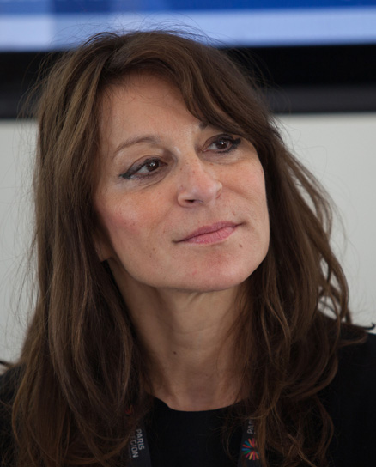
Over the past twenty years, Borina Andrieu has developed the presence of Wilmotte & Associés Architectes in Europe, Brazil, Russia, the Middle-East and Asia, contributing to the transmission of Jean-Michel Wilmotte’s work around the world. Multilingual and with a strong knowledge in diplomatic and international trade relations, Borina Andrieu has built an extensive worldwide network. Her understanding of strategic considerations concerning legal and budget issues in large scale architectural projects allows her to actively consolidate the decisions of W&A to meet the needs of prestigious private and public clients.
Acutely concerned with the preservation of patrimonial heritage but also farsighted regarding the reflection on the City of Tomorrow and how to think about architecture in a responsible and intelligent way, Borina Andrieu shares her vision, know-how and values through several conferences around the world.
DISTINCTION: Knight of the French Legion of Honor / Knight of the Order of Arts and Letters
Sophie Caroline Huisman

Experienced Director of International Relations with a demonstrated history of working in the education management industry. Strong business development professional skills in International Relations, Event Management, Public and Media Relations, Corporate Communications, in French and English.
She has been working for 6 years at ESTP Paris which is the leading school for construction in the broadest sense of the word: design, construction, operation of buildings and infrastructures. The school has existed since 1891.

Radivoje Lovrić
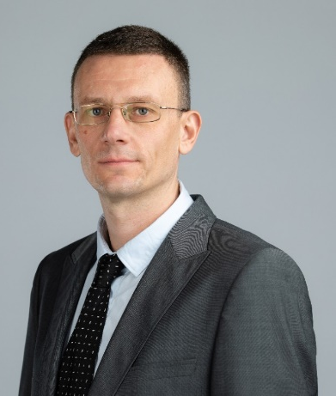
Human Resources Manager at the French company Saint-Gobain, Associate to CIPD, possessing over 15 years of experience in international companies. As a member of the management team, his focus is on implementation of business strategies by development of different HR actions, including workforce planning, working processes improvement and introduction of proactive employee relations.
M. Lovrić’s areas of expertise are: Organizational Change and Development in companies. Labor Relations and Negotiation. Companies’ performance management. Employees Selection and Recruitment.

Benoit Chambost
With 17 years of experience within Vinci and currently joint venture director and site manager for Vinci Construction Grands Projets, Benoit Chambost is one of the managers in charge of the extension of Belgrade airport. This project is worth €262,000,000.
Vinci Terna Construction JV doo is a construction company established for the Project of reconstruction and extension of the Airport Nikola Tesla Belgrade. The project includes the renovation and extension of Terminal, utilities, airside and landside infrastructure works. Joint venture has been formed between Vinci Construction Grands Projets and GEK Terna Group.

