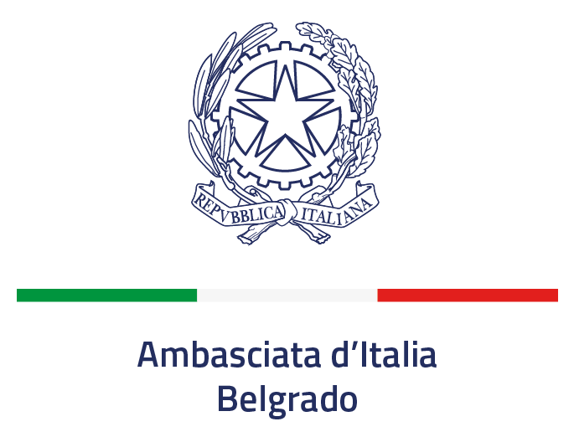

“Science, She Says!”

Purpose
The Italian Ministry of Foreign Affairs and International Cooperation (MAECI) is willing to establish the “Science, She Says! Award” to recognize an outstanding junior female scientist who has remarkably contributed to the advancement of science and technology, while performing her research in one of the following regions:
Africa and the Middle East
Asia and the Pacific
Europe
Central and South America and the Caribbean
North America
One candidate will be selected for each of the five regions, the determining factor being the place of work for at least the last 4 years.
The first edition of the Award bestowed will take place during the Italian Scientific Attachés Conference, to be held in Padua in October 2022. All fields of science and technology will be considered. The award will consist of an engraved medal and a diploma from the Italian Ministry of Foreign Affairs and International Cooperation.
Eligibility
- The “Science She, Says! Award” is assigned to an outstanding female scientist for her contribution to the advancement of bilateral scientific cooperation in any field of science and technology, through their activity in one of the regions mentioned above (specify Region):
- The nominee should be resident in the country where she is nominated for the award, at least since January 1st 2018.
- The nomination should be submitted by an eminent scientist who is holding a leading position in a Scientific Academy, University, Research Institute or S&T Department of the Government of the country in which the nominee is working. Self-nominations are not eligible, nor are nominations from immediate family members. Teams are not eligible for the nomination. Qualified nominators may be:
➢ Heads of University or Scientific Institutions,
➢ Members of Academies of Science,
➢ Holders of Research Chairs,
➢ Full professors,
The nominee should be an established scientist with an excellent academic and/or scientific career and a recognized track record of research achievements. She should have joint publications in high impact journals and/or should have developed technologies supported by international patents. Research activities within multilateral organizations hosted in one of the regions mentioned above (Europe) will be considered as well.
- Age limit: up to 40 years old at the time of publication of this notice.

Evaluation Criteria and Mode of Selection
Nominees will be evaluated on the basis of the following criteria:
- The scientific impact of the nominee’s work and research
- Relevance of the nominee’s work to Italy’s bilateral S&T cooperation with one the regions mentioned above (Europe)
- Potential for significant, long-term collaboration
- Promotion of young researchers’ mobility (incoming/outgoing) to foster the creation of bilateral research teams
- Nominee’s contribution to creative/innovative collaboration models
- Nominee’s capacity to create/improve contacts with the Italian research community.
The Award Committee, chaired by the Head of Office IX of the Directorate General for Cultural and Economic Promotion and Innovation of MAECI, will be composed by the Presidents and/or Representatives of the major Italian Research and Academic Institutions.

How to Apply
The Call for Nominations will be published on the websites of the Embassy of Italy in Belgrade (https://ambbelgrado.esteri.it)
Any scientist and institution willing to present a nomination may submit the format herewith enclosed, duly completed, to the following email address: segret.belgrado@esteri.it

Nomination Form

Nominee
Name:
Institution:
Present Position:
Postal address:
Email address:

Nominator
Name:
Institution:
Present Position:
Postal address:
Email address:

Please send the form to the Embassy of Italy in Belgrade until 12th of September 2022, together with the following attachments in .pdf file:
- Short motivation for awarding this prize (maximum 100 words) signed by the “nominator”.
- Nominee’s major scientific achievements (maximum 1 page).
- Nominee’s short CV (maximum 2 pages) according to the applicable law in data protection.
- List of nominee’s most important publications (maximum 1 page).
- Nominee’s activities with the Italian scientific community (maximum 1 page)
- Optional letters of support for the nomination (maximum 2 letters of maximum 1 page each) The letters of support shall be provided by eminent scientists other than the nominator.

All information provided will be treated according to the Italian Law (Legge 196/2003 and Regolamento UE 2016/679)

Attachment 1 (to be signed by the applicant)

Information on the protection of individuals with reference to the processing of personal data (General Data Protection Regulation (EU) 2016/679, art. 13)

The processing of personal data required for the purpose of participating in the “Science, She Says award” will conform to the principles of lawfulness, correctness and transparency in order to protect the fundamental rights and freedom of individuals.
To this purpose, the following information is provided:
1. The Data Controller is the Ministry of Foreign Affairs and International Cooperation (MAECI) of the Italian Republic which, in this specific case, operates via Office IX DGSP – (dgsp-09@esteri.it; tel. 0039 0636913619; + contatti SEDE).
2. For inquiries or complaints, interested parties are entitiled to address the MAECI data protection officer / DPO [responsabile protezione dati / RPD] (mailing address: Ministero degli Affari Esteri e della Cooperazione internazionale, Piazzale della Farnesina 1, 00135 ROMA, telephone: 0039 06 36911 (switchboard), email: rpd@esteri.it, certified email [pec]: rpd@cert.esteri.it).
3. The personal data requested are needed to participate in the selection procedure of the present the call. The processing of recipients’ personal data is meant exclusively for the purposes of the selection procedure for the award of the prize “Science She Says” .
4. The legal bases applicable are: the “Science She Says award” selection procedure; the Italian legislation on administrative transparency; the applicant’s consent; the EU Data Protection Regulation (EU 2016/679). The applications will be dismissed in the following cases:
- No data are provided, or
- the applicant’s consent is withdrawn

5. Data processing, performed by especially appointed personnel, will be carried out by manual and automated modalities exclusively for the purposes of the present selection procedure.

6. Personal data provided will be exclusively processed by persons responsible for the selection procedure, whose interest is legitimate according to Italian law, or to whom such data is owed by legal requirements. The recipient’s CV and name will be released to the press.

7. Personal data of the prize recipients shall be retained indefinitely for documentation. The remaining applicants’ personal data shall be retained for a maximum of 10 years after the award ceremony.
8. Applicants may request access to their personal data as well as their correction. Within the limits established by current legislation and without prejudice to any consequences on the outcome of the selection procedure, applicants may also request the cancellation of such data, as well as limitations of – or opposition to - data processing. In such cases, applicants must submit a specific request to the MAECI data protection officer (see art. 1).
9. If you believe your rights have been violated, a complaint may be addressed to the MAECI DPO (see art. 2.). Alternatively, you may contact the Italian Data Surpervisory Autorhitiy [Garante per la Protezione dei Dati personali] (mailing address: Piazza Venezia, 11 00187 ROMA, telephone: 0039 06 696771 (switchboard), email: protocollo@gpdp.it, certified email: protocollo@pec.gpdp.it)

Date and Place Signature

